AEP Profile toolkit — configuration guide
This guide helps you configure Adobe I/O authentication and the Profile Viewer web app so your team can query profiles, use search, stream profile updates, and related features. All secrets stay in local .env files — never commit credentials.
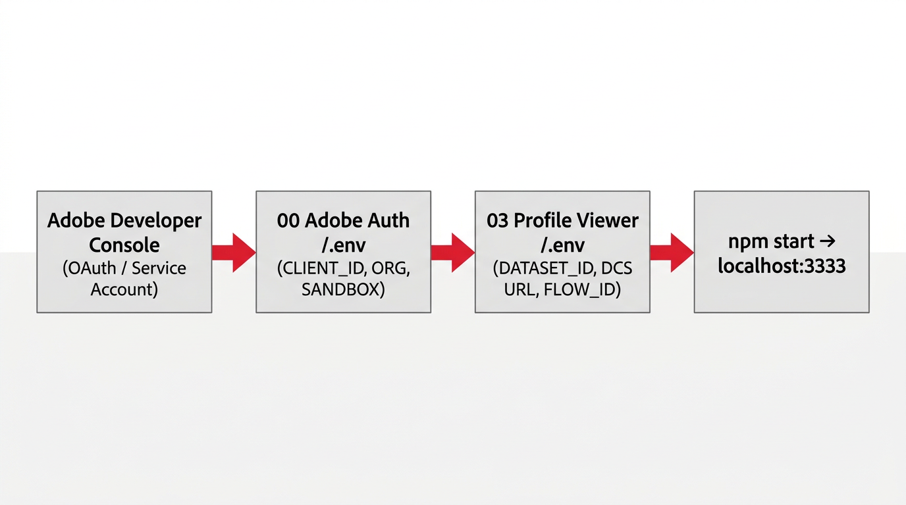
Figure 0 — Configuration flow (overview diagram)

1. Prerequisites
- Node.js (LTS) installed.
- Access to Adobe Experience Platform (sandbox) and Adobe Developer Console.
- Repository: AEP Profile project (folders 00 Adobe Auth, 03 Profile Viewer).

2. Adobe I/O — 00 Adobe Auth
Create or open a project in Adobe Developer Console with a Service Account (OAuth) integration. Copy credentials into 00 Adobe Auth/.env.
Adobe Developer Console
[Add screenshot] Figure 1 — Service Account / OAuth credentials (example)

Required variables (00 Adobe Auth/.env)
Variable | Description
ADOBE_CLIENT_ID | API Key (Client ID) from the integration
ADOBE_CLIENT_SECRET | Client secret
ADOBE_IMS_HOST | e.g. ims-na1.adobelogin.com or ims-eu1.adobelogin.com
ADOBE_SCOPES | Space-separated scopes matching your project
ADOBE_ORG_ID | Org ID, e.g. XXXXX@AdobeOrg
ADOBE_SANDBOX_NAME | AEP sandbox name, e.g. production sandbox short name

Verify: From 00 Adobe Auth run: npm install then npm run test-auth. You should see config and token length without errors.

Postman mapping (optional)
Postman / environment | .env variable
API_KEY | ADOBE_CLIENT_ID
CLIENT_SECRET | ADOBE_CLIENT_SECRET
ORG_ID / IMS_ORG | ADOBE_ORG_ID
x-sandbox-name | ADOBE_SANDBOX_NAME

3. Profile Viewer — 03 Profile Viewer
Copy .env.example to .env in the Profile Viewer folder. Edit values for your org.
- AEP_QUERY_PROFILE_DATASET_ID — Profile dataset name or ID for Query Service search (required for search).
- AEP_PROFILE_STREAMING_URL — DCS collection URL from HTTP API source (for Update profile streaming).
- AEP_PROFILE_FLOW_ID — Dataflow ID (x-adobe-flow-id) for that streaming pipeline.
- Optional: AEP_PROFILE_STREAMING_API_KEY, envelope flags, event/trigger URLs — see .env.example comments.

4. Streaming profile updates (AEP UI)
- Sources → HTTP API: create connection; copy collection URL.
- Set up dataflow to the Profile dataset; configure Data Prep mapping to your schema.
- From dataflow API Usage / details: note Dataflow ID and Dataset ID.
- Put collection URL and flow ID in Profile Viewer .env; restart npm start.
[Add screenshot] Figure 2 — AEP Sources: HTTP API (example)
[Add screenshot] Figure 3 — Dataflow / API usage (example)

5. Run the app
From 03 Profile Viewer: npm start
- http://localhost:3333 — profile lookup by email
- http://localhost:3333/search.html — profile search (partial email)
Do not open HTML via file:// or Live Server; API routes require the Node server.
[Add screenshot] Figure 4 — Profile Viewer in the browser (example)

6. Security notes
- .env is gitignored — do not commit secrets.
- Production: consider Azure Key Vault for client ID/secret (see 00 Adobe Auth README).

7. Adding your own screenshots
Save PNG files under AEP Profile/documentation/screenshots/ (see WHICH-FILES.txt there for filenames), then run npm run generate in the documentation folder again to refresh this Word file and the PowerPoint deck.

